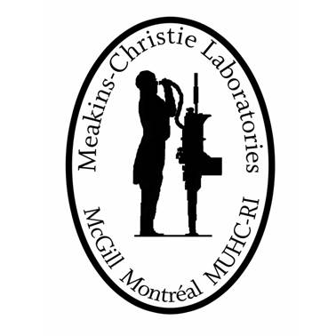
Meakins-Christie Laboratories Postdoctoral Training Program
Professional Development Plan and
Annual Progress Report for Postdoctoral Fellows

Objectives: To provide a concrete structure for PDF training that will include the necessary scientific training as well as the appropriate resources for professional development to ensure success in future career goals.
Structure: The committee is to be selected by the supervisor(s) and the PDF and must be comprised of the supervisor(s) and at least two additional faculty members (Meakins or McGill). The committee will meet twice in the first year. The first meeting will occur 2-3 months after initial recruitment to map out the central hypotheses of the project and the experimental approaches. Subsequent meetings will take place following the annual Work-in-Progress presentations.
Documentation: This form must be completed at every meeting. Once completed, return a copy to your supervisor and to Dr. Inga Murawski (inga.murawski@mail.mcgill.ca).

Name of postdoctoral fellow:

Supervisor(s):

Start date of PDF:

Project title:

Department:

Date of Progress Report/Meeting:

Name of Committee Member 1:

Committee Member 2:

Signed by:

Postdoctoral fellow date

Supervisor date

Supervisor (if more than one) date

A. Professional Development Plan
- Briefly describe the research objectives and experimental approaches for the current project.

- What are the PDF’s career goals (short and/or long-term)?

- What core competencies/skills would the PDF like to develop during his/her postdoctoral fellowship? Complete the following professional development plan in collaboration with the supervisor.
Category | Goals List each goal and by which mechanism(s) it will be achieved. | Expectations of PDF List what the PDF expects as an outcome.
To develop knowledge and research skills
- concepts
- critical thinking
- experimental design
- methodology
- novel analytical tools
- data analysis

To develop communication & interpersonal skills
- writing publications/grants
- teaching portfolio
- poster/oral presentations
- knowledge dissemination
- networking
- CV writing
- job interview skill
To develop leadership & management skills
- project management
- time management
- budget management
- strategic planning of research project
- trainee mentorship
Other skills
- describe any other skill you would like to develop during your PDF

B. PDF Evaluation
- PDF Self-Evaluation. Referring to the table in section A, which expectations did you meet? Which were you unable to meet, and why? What do you perceive as your own strengths and weaknesses?

- Describe the major research accomplishments this year.

- Describe new techniques/expertise acquired this year.

- Include references (e.g. manuscripts, abstracts) submitted or published this year. In each case, underline your name in the author list.

- Has the PDF been involved in writing grant proposals and/or manuscripts? If yes, describe the level of involvement.

- List honors/awards and any funding (external/internal fellowships) that were received this year.

- Describe present and new collaborations and what the PDF’s role was in establishing these collaborations.

- Include any training activities that the PDF participated in (e.g. skillset sessions, conference/workshop attendance, career development activities, communication/interpersonal skills, teaching/learning, critical thinking, knowledge translations, etc…)

C. Future Research Plan
Briefly describe the research plan for the upcoming year (To be prepared by the PDF and approved by the supervisor(s)).

D. Supervisor(s)’ Evaluation
Describe the main achievements, strengths, challenges, and areas for improvement.

